One-page Abstract

A. Author*, B. Author and C. Author

* Dept of Mechanical Engineering, University of Memphis, USA 38152, esd@memphis.edu (Corresponding author)

1 Purpose
This document is a template for Microsoft Word versions. It provides instructions for authors that will be presenting an abstract at the International Society on Acoustic Emission (ISAE) Conference. Submission of an abstract to the Conference is mandatory and 1 page limit is suggested. The abstract includes the following four aspects; authors can modify the content according to your article.Table 1 gives the font sizes and formats that are used in Abstract-Template-ISAE.doc. Do not change the font sizes or line spacing to squeeze more text into a limited number of pages. Use italics for emphasis; do not underline.
Table 1 Font sizes and format
Element | Font Size | Font Type | Spacing
Title | 24 pt | Normal | 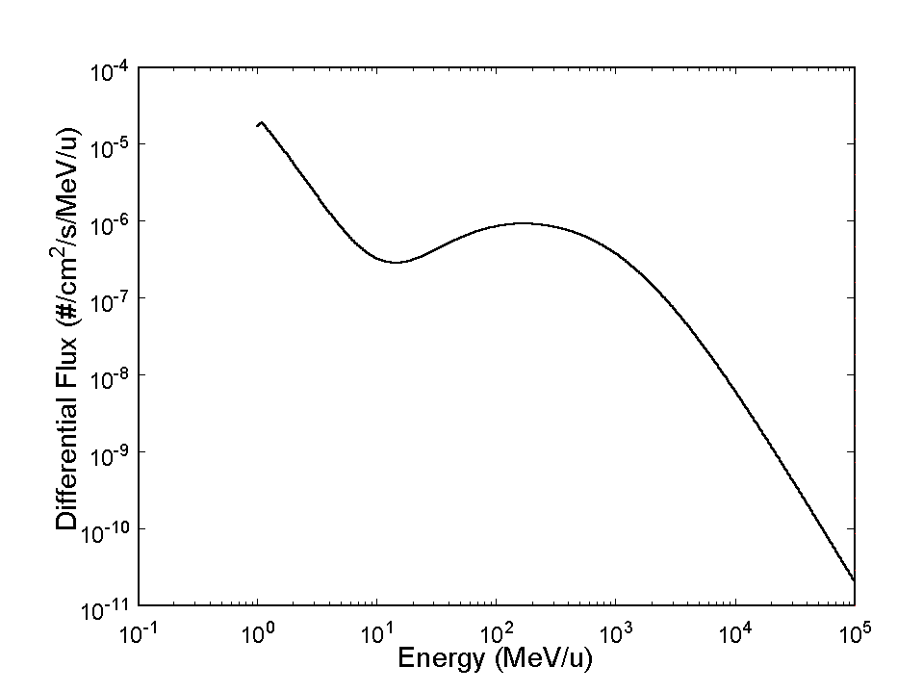  N/A
Authors | 11 pt | Normal | 16 pt before, 1 pt after
Abstract | 10 pt | Bold | N/A
Heading 1 | 11 pt | Small Caps | 12 pt before, 4 pt after
Heading 2 | 11 pt | Italics | 6 pt before, 3 pt after
Heading 2 | 10 pt | Italics | 6 pt before, 3 pt after
Heading 3 | 10 pt | Italics | N/A
Text | 10 pt | Normal | “Multiple” at 1.05
Footnote | 8 pt | Normal | N/A
Table Title | 8 pt | Small Caps | N/A
Figure | 8 pt | Normal | N/A
References | 8 pt | Normal | N/A
Fig. 1 The cosmic ray iron ion counts

2 Methods
Use either the Microsoft Equation Editor or the MathType add-on for all math objects in your paper (Insert | Object | Create New | Microsoft Equation or MathType Equation). "Float over text" should not be selected.

3 Results
Use either SI (MKS) or CGS as primary units. (SI units are strongly encouraged.) English units may be used as secondary units (in parentheses). An exception is when English units are used as identifiers in trade, such as "3.5 inch disk drive." Avoid combining SI and CGS units, such as mass in kilograms and volume in cubic centimeters. This often leads to confusion because equations may not balance dimensionally. If you must use mixed units, clearly state the units for each quantity in an equation.

4 Conclusion

4.1 References
Number citations consecutively in square brackets [1]. The sentence punctuation follows the brackets [2]. Multiple references [2], [3] are each numbered with separate brackets [1]–[3]. When citing a section in a book, please give the relevant page numbers [2]. In sentences, refer simply to the reference number, as in [3].

4.2 Equations
Number equations consecutively with equation numbers in parentheses flush with the right margin, as in (1). Punctuate equations when they are part of a sentence, as in
$\int{ F(r,ϕ)} \text{dr} dϕ=[{σr}_{2} (2μ_{0})] ⋅ \int{ \text{exp}}(−λ|z_{j}−z_{i}| ) λ^{−1} J_{1}(λ r_{2}) J_{0}(λ r_{i}) dλ \text{.}$ (1)
Be sure that the symbols in your equation have been defined before the equation appears or immediately following. Refer to "(1)," not "Eq. (1)" or "equation (1)," except at the beginning of a sentence: "Equation (1) is ..."

References
- F. W. Sexton, D. M. Fleetwood, M. R. Shaneyfelt, P. E. Dodd, and G. L. Hash, "Single event gate rupture on thin gate oxides," IEEE Trans. Nucl. Sci., vol. 44, no. 6, pp. 2345-2352, Dec. 1997.

